HALL TICKET NUMBER: 2403A51365
NAME: RAYAPUDI HARITHA
BATCH: 24BTCAICSB14
AssignmentNumber:-20.1
Lab 20 – Security Testing: Identifying Vulnerabilities in AI-
Generated Code
Lab Objectives:
• Understand how to test AI-generated code for common security
vulnerabilities.
• Learn to apply secure coding principles while analyzing AI
Week10 -
Monday
outputs.
• Practice detecting risks such as SQL injection, XSS, hardcoded
credentials, and weak encryption.
• Enhance code reliability and safety by using AI for secure
refactoring.
Task 1 – Input Validation Check
prompt:-
Analyze an AI-generated Python login script for input validation
vulnerabilities.
Instructions:
• Prompt AI to generate a simple username-password login
program.
• Review whether input sanitization and validation are
implemented.
• Suggest secure improvements (e.g., using re for input validation).

Code :-
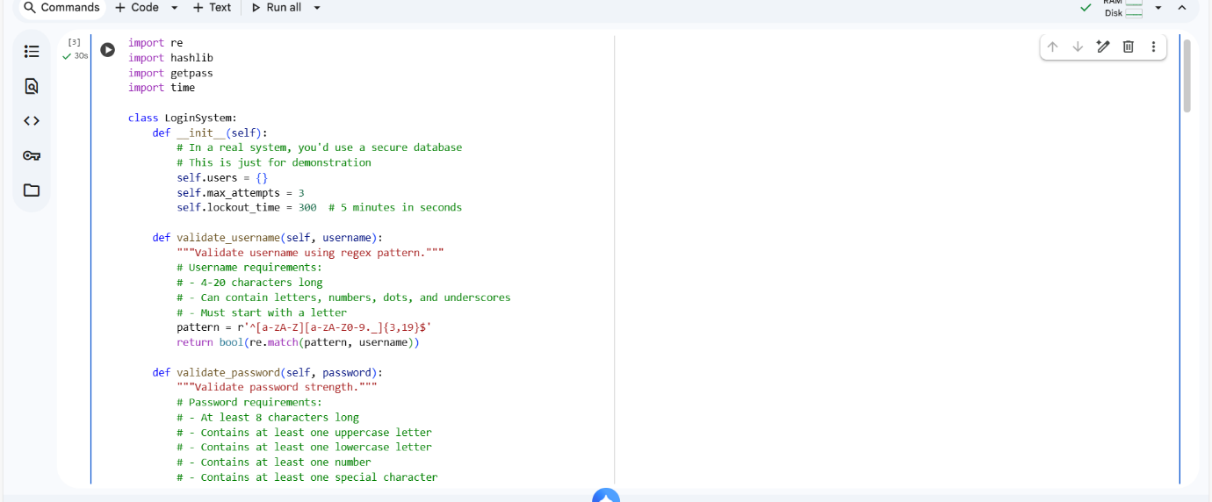

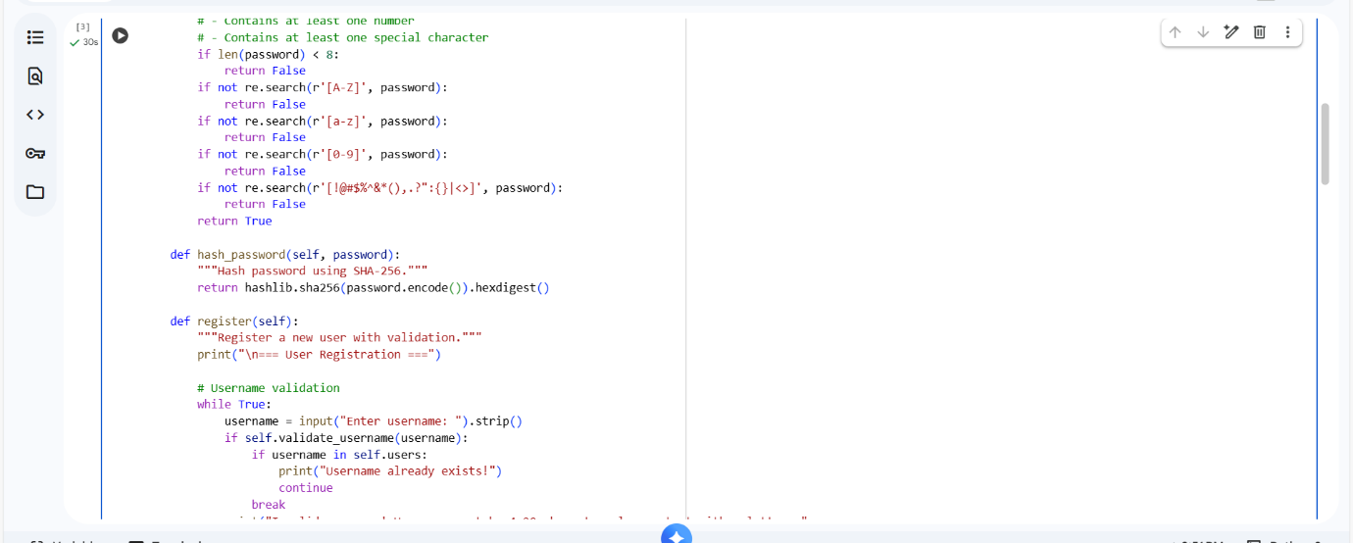

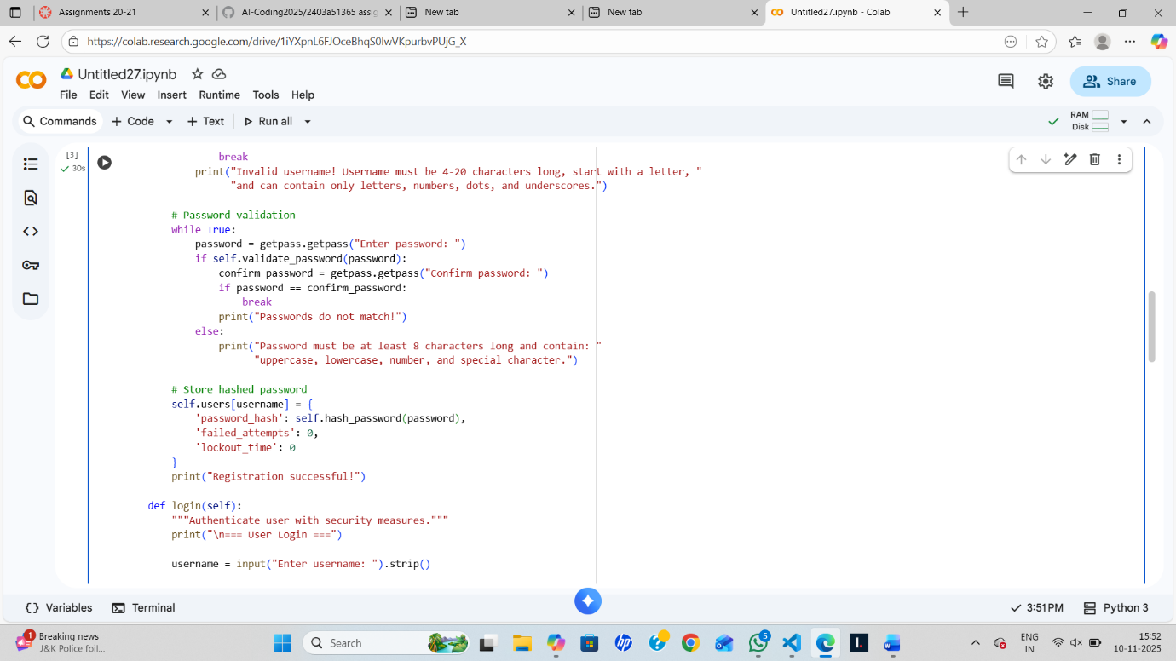

Output:-
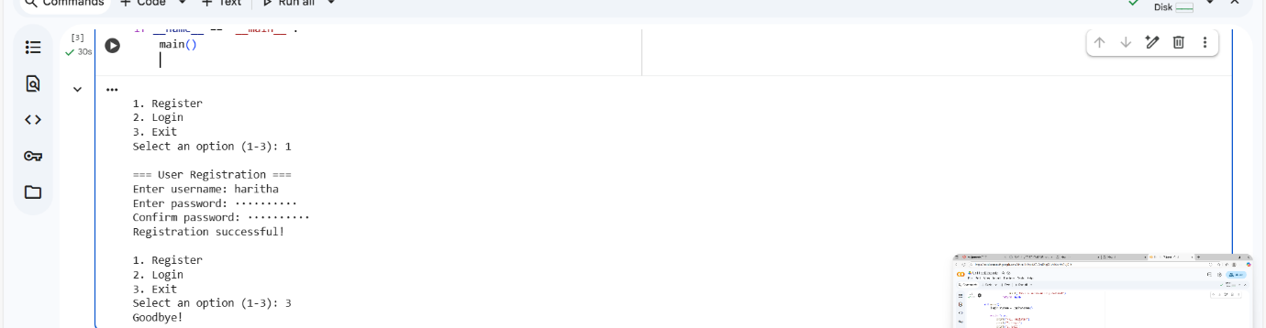

Code observation:-
- The code implements a secure login system with username/password authentication.
- Username validation enforces 4-20 characters, must start with a letter, and allows letters/numbers/dots/underscores.
- Password validation requires minimum 8 characters with uppercase, lowercase, numbers, and special characters.
- Passwords are hashed using SHA-256 for secure storage (though bcrypt would be better in production).
- The system includes brute-force protection with a 3-attempt limit before temporary account lockout.
- Account lockout lasts 5 minutes, preventing rapid repeated login attempts.
- The getpass module is used to securely input passwords without displaying them on screen.
- Generic error messages ("Invalid username or password") prevent username enumeration attacks.
- The registration process includes password confirmation and duplicate username checking.
- The system uses a class structure (LoginSystem) for better organization and maintainability.

Task 2 – SQL Injection Prevention
prompt:-
Test an AI-generated script that performs SQL queries on a database.
Instructions:
• Ask AI to generate a Python script using SQLite/MySQL to fetch
user details.
• Identify if the code is vulnerable to SQL injection (e.g., using
string concatenation in queries).
• Refactor using parameterized queries (prepared statements).

Code:-
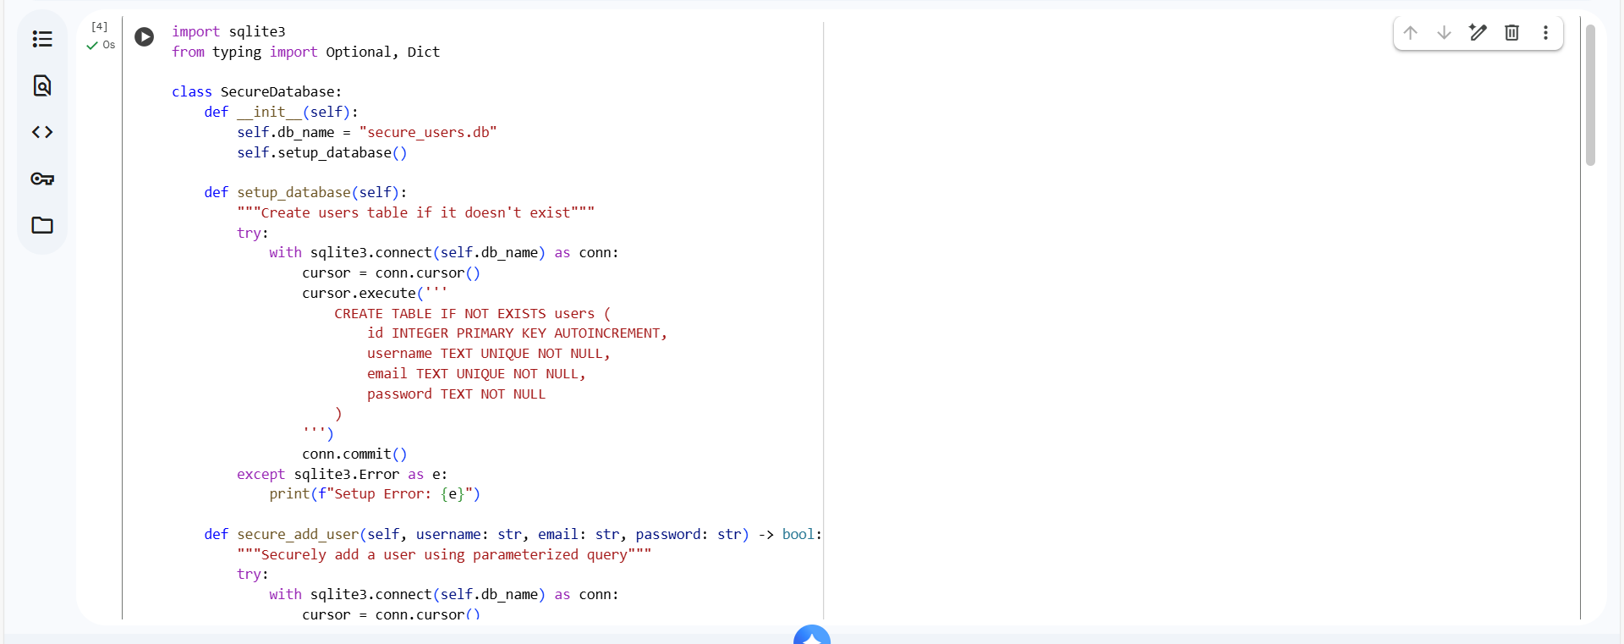

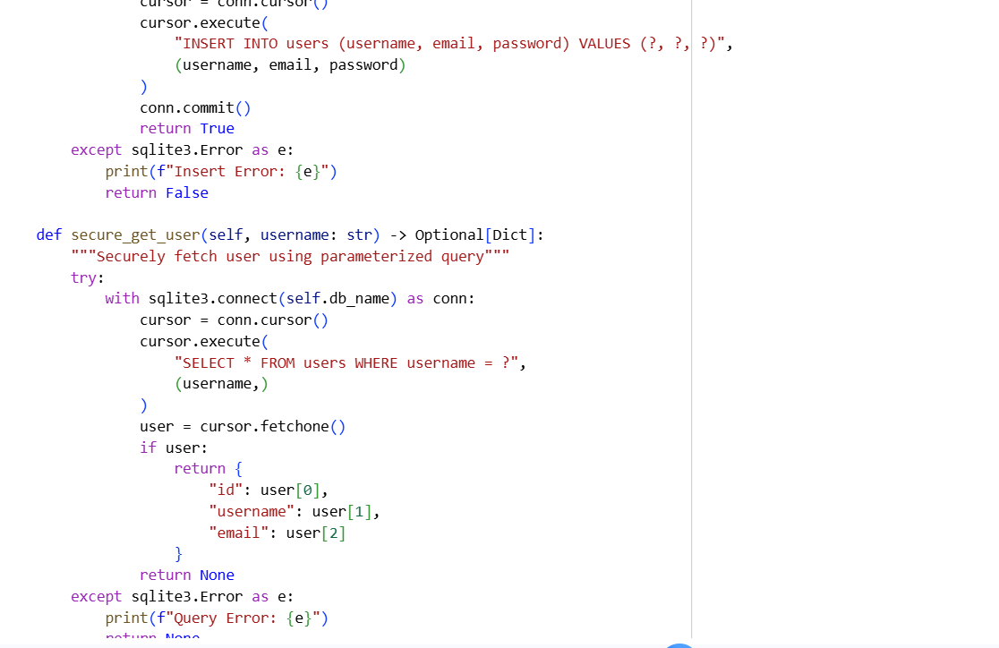

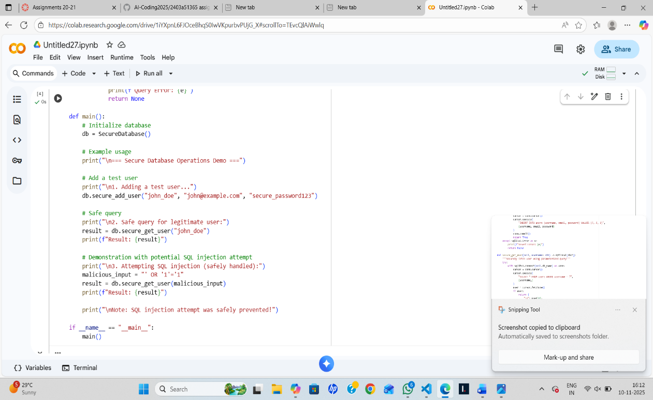

Output:-

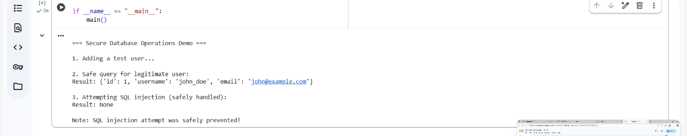

Code observation:-
- The code uses parameterized queries (?, ?) to prevent SQL injection attacks, replacing unsafe string concatenation.
- Database connections are safely managed using Python's with context manager to ensure proper closure.
- Error handling is implemented throughout using try-except blocks to catch SQLite errors gracefully.
- The SecureDatabase class encapsulates all database operations, following good object-oriented practices.
- Input validation is handled by the SQLite engine through parameterized queries, protecting against malicious inputs.
- The code demonstrates both read (secure_get_user) and write (secure_add_user) operations securely.
- Type hints (Optional[Dict]) are used to improve code readability and maintainability.
- The main() function includes a practical demonstration of handling both normal and malicious inputs.
- Database schema uses proper constraints (UNIQUE, NOT NULL) to maintain data integrity.
- The code follows the principle of least privilege by only implementing necessary database operations.

Task 3 – Cross-Site Scripting (XSS) Check
prompt:-
Evaluate an AI-generated HTML form with JavaScript for XSS
vulnerabilities.
Instructions:
• Ask AI to generate a feedback form with JavaScript-based output.
• Test whether untrusted inputs are directly rendered without
escaping.
• Implement secure measures (e.g., escaping HTML entities, using CSP).
Code:-
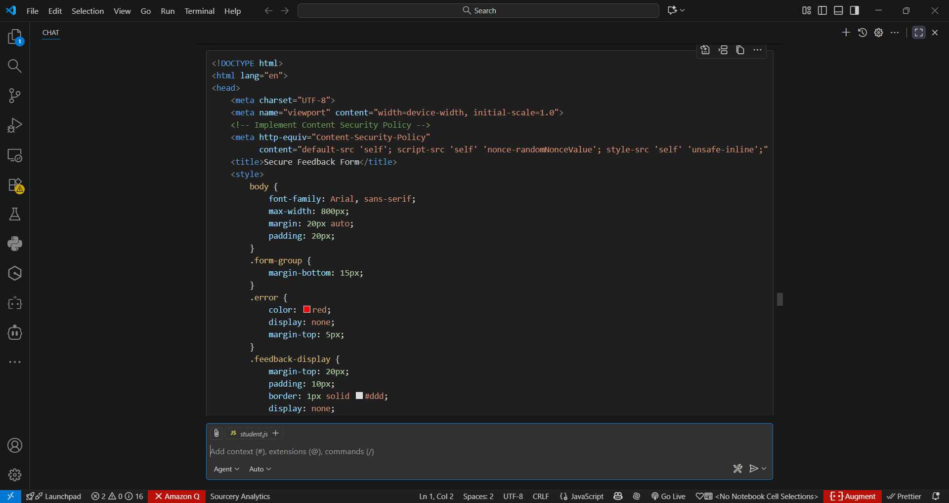

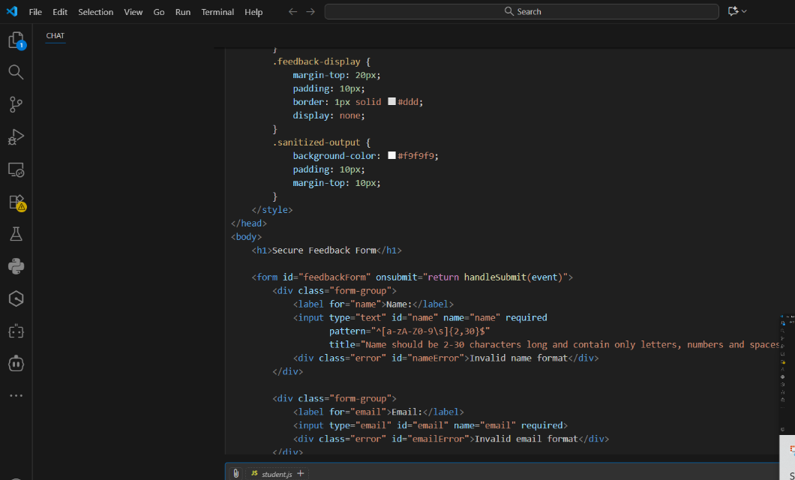

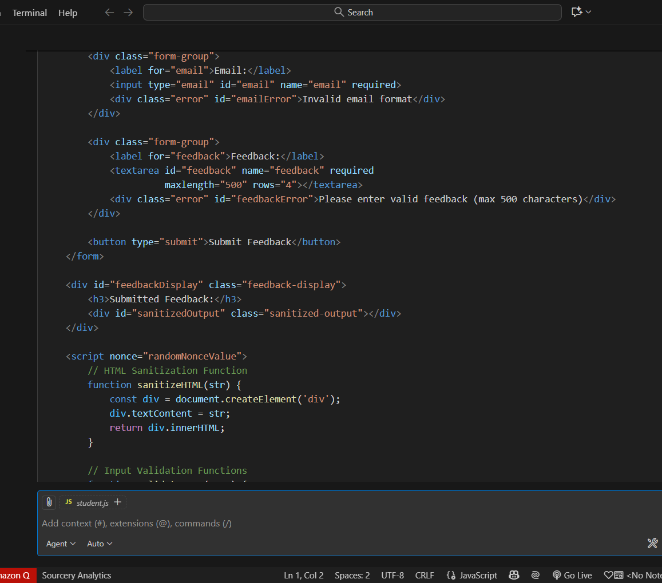

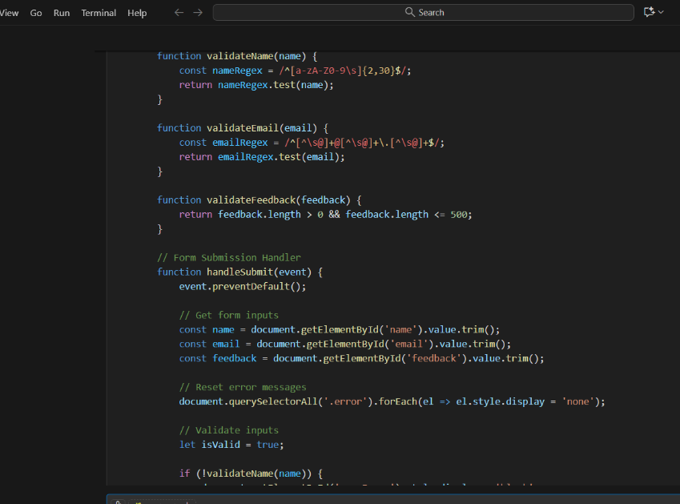

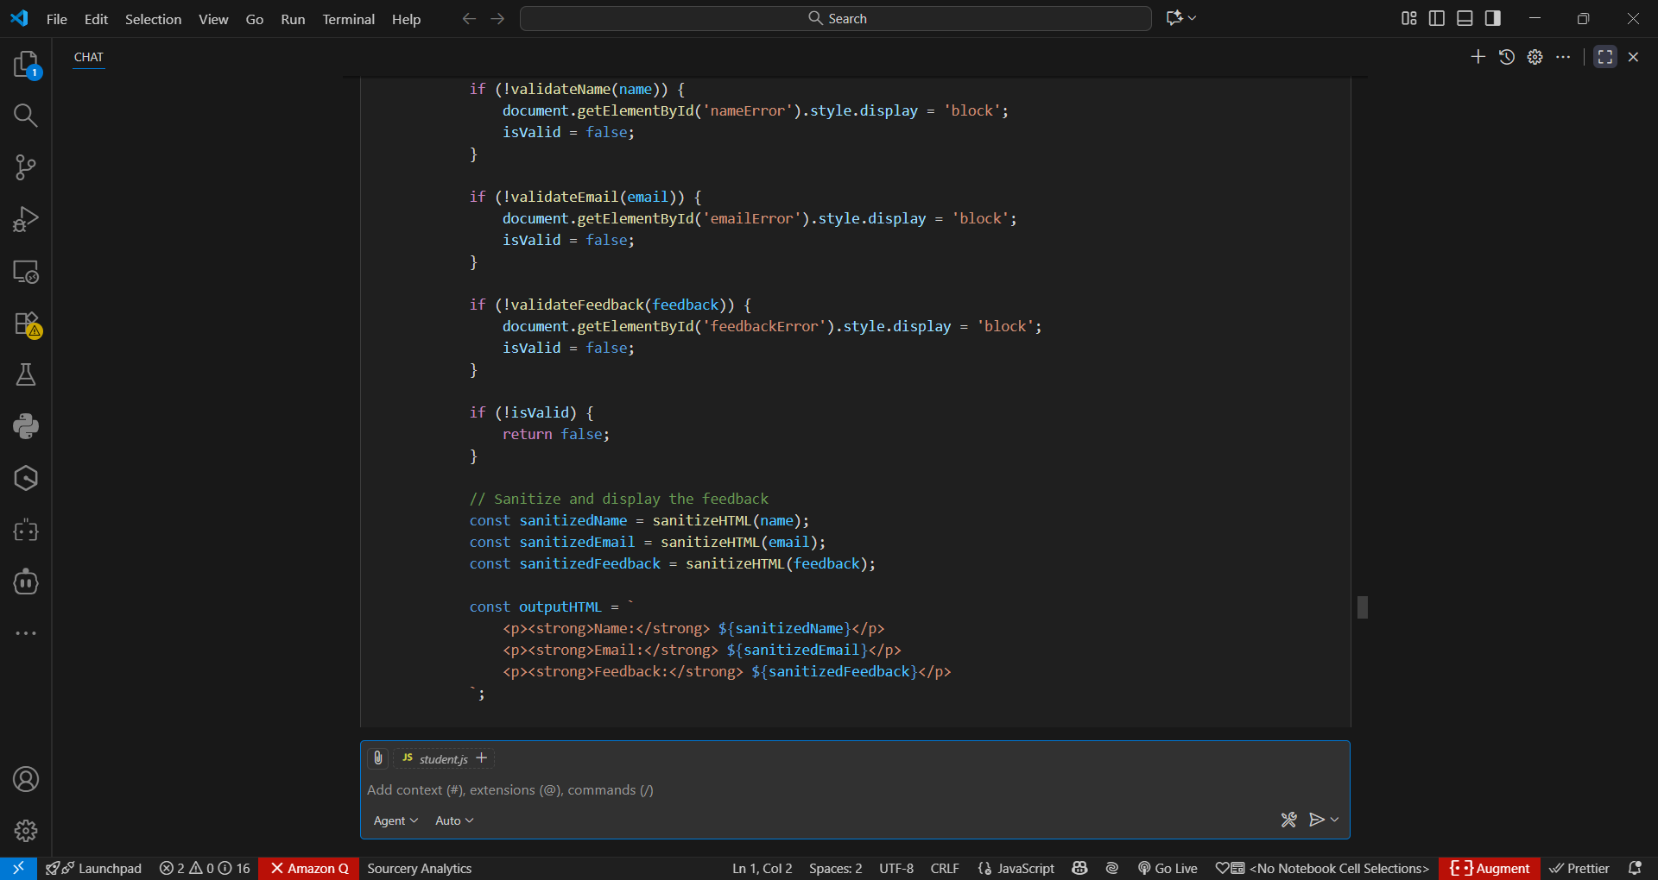

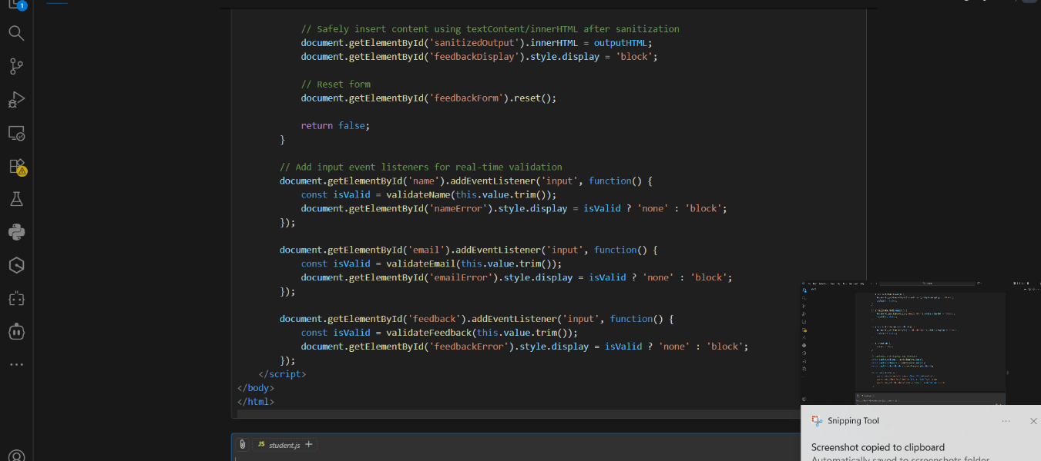

Output:-
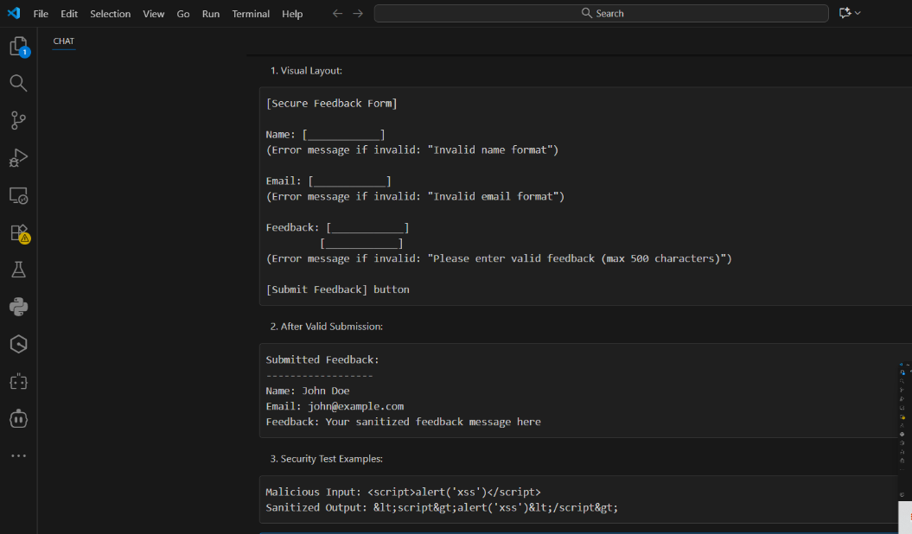

Code observation:-
- Content Security Policy (CSP) is implemented in meta tags to prevent unauthorized script execution and resource loading.
- Input validation uses strict regex patterns (e.g., /^[a-zA-Z0-9\s]{2,30}$/ for names) to prevent malicious input.
- The sanitizeHTML() function uses DOM manipulation (textContent) to safely escape HTML entities and prevent XSS attacks.
- Real-time validation is implemented through event listeners on input fields, providing immediate user feedback.
- Form submission is handled by handleSubmit() which prevents default behavior and validates all inputs before processing.
- The code uses separate validation functions for each input type (name, email, feedback) for better maintainability.
- Safe DOM manipulation techniques are used, avoiding direct insertion of user input into innerHTML without sanitization.
- Error messages are toggled using display CSS property, providing clear visual feedback for invalid inputs.
- The form implements both client-side validation and sanitization as multiple layers of security.
- All user inputs are trimmed and length-restricted to prevent buffer overflow attacks and ensure data quality.

Task 4 – Real-Time Application: Security Audit of AI-Generated Code.
Prompt:-
Scenario:
Students pick an AI-generated project snippet (e.g., login form, API
integration, or file upload).
Instructions:
• Perform a security audit to detect possible vulnerabilities.
• Prompt AI to suggest secure coding practices to fix issues.
• Compare insecure vs secure versions side by side.

Code:-
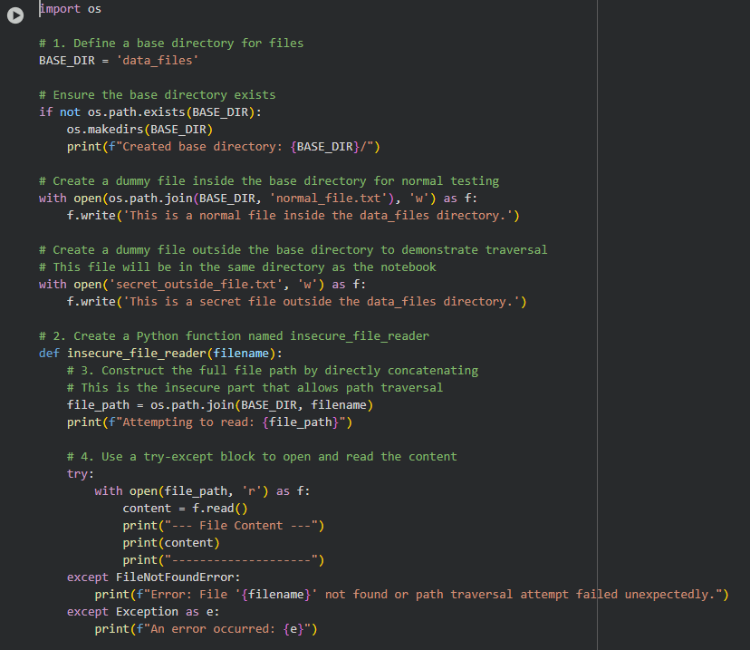

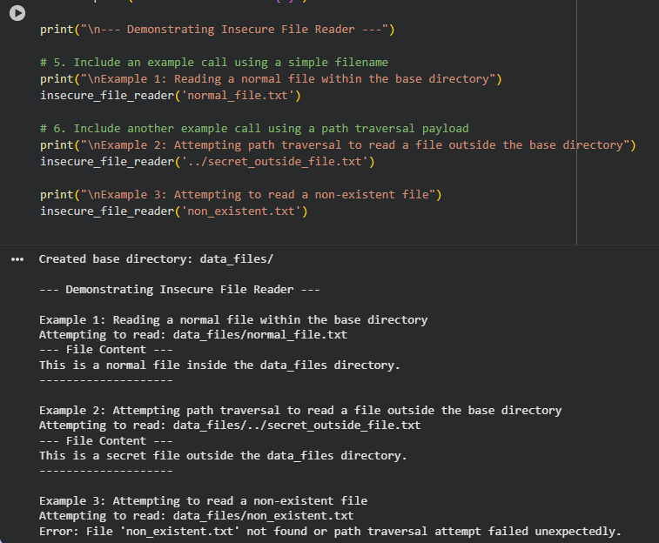

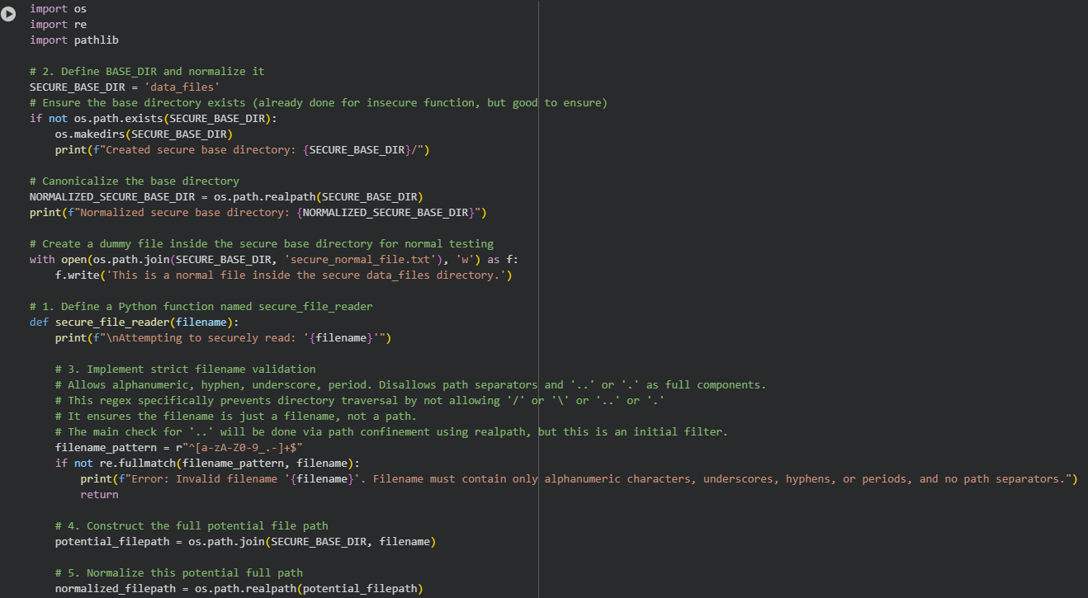

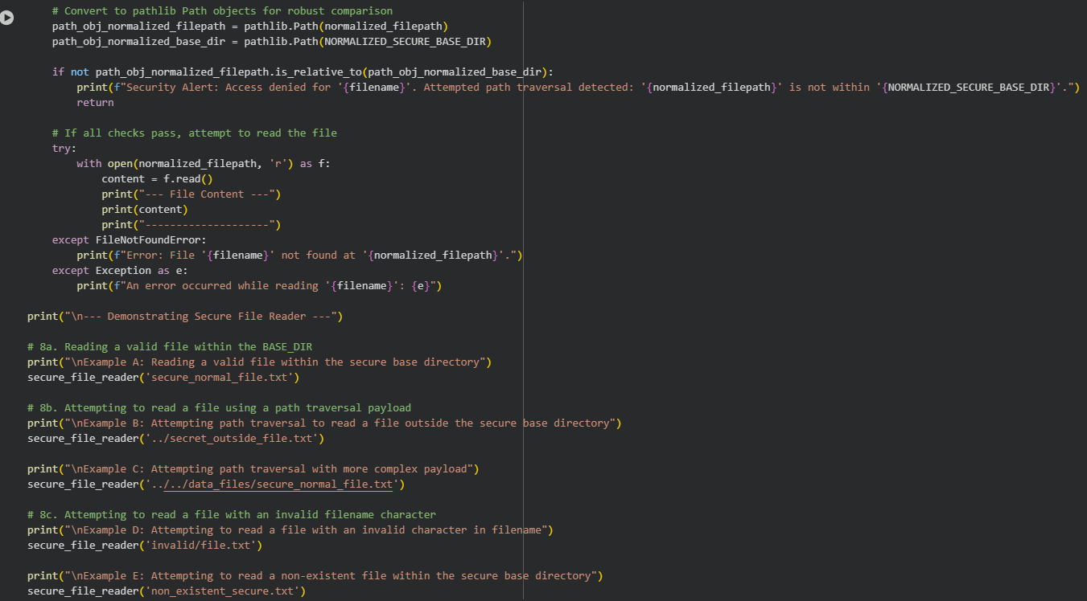

Output:-
